**ISSN: 2979-935X**

www.ijedal.com

2025

Volume 4 Issue 1

June

International Journal of Educational Administration and Leadership: Theory and Practice

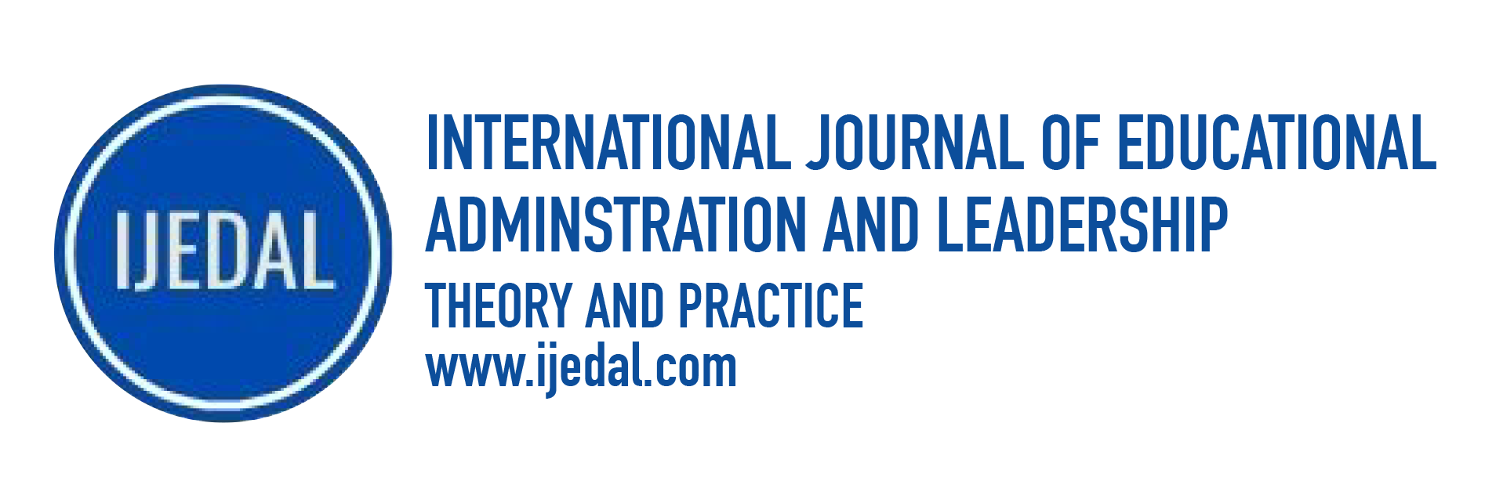

**Editors**

Dr. Pınar MERT

**Editors**

Dr. Pınar MERT, Istanbul Sabahattin Zaim University, Istanbul, Turkey

**Editorial Board**

Dr. A. Faruk Levent, Marmara University, Turkey

Dr. Cemal Aküzüm, Dicle University, Turkey

Dr. Chin-Lung Chien, Kaohsiung Medical University, Taiwan

Dr. Dennis Beach, University of Gothenburg, Sweden

Dr. Fatma Özmen, Cyprus University of Health and Social Sciences, Cyprus

Dr. Gang Zhu, Texas A&M University, USA

Dr. Hanifi Parlar, Istanbul Ticaret University, Turkey

Dr. Hüseyin Serçe, Selcuk University, Turkey

Dr. Kuan-Ming Chen, National Academy For Educational Research, Taiwan

Dr. Luminița CATANĂ, Institute of Educational Sciences Bucharest, Romania

Dr. Metin Işık, Ahi Evran University, Kırşehir

Dr. Muhittin Çalışkan, Necmettin Erbakan University, Turkey

Dr. Orkun Osman Bilgivar, Istanbul Sabahattin Zaim University, Turkey

Dr. Ramazan Cansoy, Karabuk University, Turkey

Dr. Şebnem Yazıcı, Fatih Sultan Mehmet Vakif University, Turkey

Dr. Tharwat M. El-Sakran, American University of Sharjah, United Arab Emirates

Dr. Tsung-Hau Jen, National Taiwan Normal University, Taiwan

|  |  |
| --- | --- |
| Table of Contents | |
| **The Role of Organizational Values in Educational Institutions: A Systematic Review**  *Mustafa Taktak* | **1-8** |
| **The Predictive Effect of Transferred Psychologıcal Trauma on Teachers' Psychological Flexibility**  *Osman Söner, Nur Koşar, Sinan Civaklı, Nihat Karasu, Mesut Tokmak* | **9-18** |